Trinity Cathedral
Of The Diocese of New Jersey



August 17, 2025 – Pentecost 10/Proper 15 – Year C
10:00 am - The Holy Eucharist: Rite Two

Celebrant & Preacher – The Rev. Julia McKeon

Our Vision:
A visible agent of God’s love in Christ, joyfully embracing all people.

801 West State Street, Trenton, NJ 08618
Phone (609) 392-3805; Fax (609) 392-2305
www.TrinityCathedralNJ.org
The Very Rev. René Rory John, Dean
WELCOME! We’re honored that you’re worshipping with us today. If you’re not familiar with our Episcopal worship service, we hope this service bulletin will help. Masks are optional within the Cathedral buildings. Please use the hand sanitizer that is provided throughout the building before and after touching any surfaces. Thank you for helping us to remain as safe as possible while enjoying in-person worship. “This is how we love one another!”

Please stand as indicated and be seated for lessons

Prelude Dr. Kerry Heimann, organ

Remain standing
Processional Hymn Hymnal # 546 Awake, My Soul, Stretch Every Nerve

Celebrant: Blessed be God: Father, Son, and Holy Spirit.
People: And blessed be his kingdom, now and for ever. Amen.

Celebrant: Almighty God, to you all hearts are open, all desires known, and from you no secrets are hid: Cleanse the thoughts of our hearts by the inspiration of your Holy Spirit, that we may perfectly love you, and worthily magnify your holy Name; through Christ our Lord. Amen.

All sing

Hymnal # S-280 Gloria in Excelsis

The Collect of the Day

Celebrant: The Lord be with you.
People: And also with you.
Celebrant: Let us pray.

Almighty God, you have given your only Son to be for us a sacrifice for sin, and also an example of godly life: Give us grace to receive thankfully the fruits of his redeeming work, and to follow daily in the blessed steps of his most holy life; through Jesus Christ your Son our Lord, who lives and reigns with you and the Holy Spirit, one God, now and for ever. Amen.

The people are seated
First Reading Lector: Cn. Clara Gregory
A Reading from the book of the prophet Isaiah (5:1-7)

Let me sing for my beloved my love-song concerning his vineyard: My beloved had a vineyard on a very fertile hill. He dug it and cleared it of stones, and planted it with choice vines; he built a watchtower in the midst of it, and hewed out a wine vat in it; he expected it to yield grapes, but it yielded wild grapes. And now, inhabitants of Jerusalem and people of Judah, judge between me and my vineyard. What more was there to do for my vineyard that I have not done in it? When I expected it to yield grapes, why did it yield wild grapes? And now I will tell you what I will do to my vineyard. I will remove its hedge, and it shall be devoured; I will break down its wall, and it shall be trampled down. I will make it a waste; it shall not be pruned or hoed, and it shall be overgrown with briers and thorns; I will also command the clouds that they rain no rain upon it. For the vineyard of the Lord of hosts is the house of Israel, and the people of Judah are his pleasant planting; he expected justice, but saw bloodshed; righteousness, but heard a cry!

The Word of the Lord.
People: Thanks be to God.

Remain seated; all sing refrain together
Psalm 80: 1–2, 8–18 Cantor: Susan Remmers

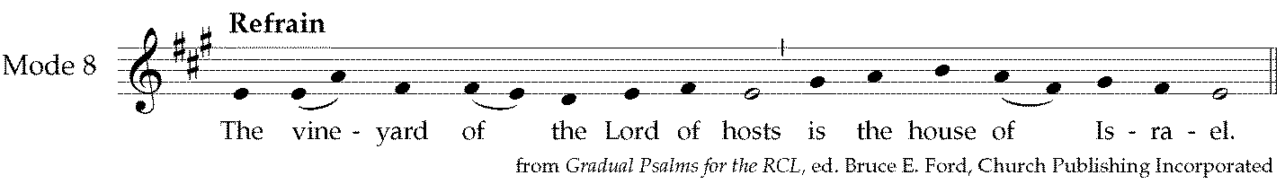

Hear, O Shepherd of Israel, leading Joseph like a flock; *
shine forth, you that are enthroned upon the cherubim.
In the presence of Ephraim, Benjamin, and Manasseh, *
stir up your strength and come to help us.
Refrain
You have brought a vine out of Egypt; *
you cast out the nations and planted it.
You prepared the ground for it; *
it took root and filled the land.
Refrain
The mountains were covered by its shadow *
and the towering cedar trees by its boughs.
You stretched out its tendrils to the Sea *
and its branches to the River.
Refrain
Why have you broken down its wall, *
so that all who pass by pluck off its grapes?
The wild boar of the forest has ravaged it, *
and the beasts of the field have grazed upon it.
Refrain
Turn now, O God of hosts, look down from heaven;
behold and tend this vine; *
preserve what your right hand has planted.
They burn it with fire like rubbish; *
at the rebuke of your countenance let them perish.
Refrain
Let your hand be upon the man of your right hand, *
the son of man you have made so strong for yourself.
And so will we never turn away from you; *
give us life, that we may call upon your Name.
Restore us, O Lord God of hosts; *
show the light of your countenance, and we shall be saved.
Refrain

Remain seated
Second Reading Lector: John Gummere
A Reading from the letter to the Hebrews (11:29—12:2)

By faith the people passed through the Red Sea as if it were dry land, but when the Egyptians attempted to do so they were drowned. By faith the walls of Jericho fell after they had been encircled for seven days. By faith Rahab the prostitute did not perish with those who were disobedient, because she had received the spies in peace. And what more should I say? For time would fail me to tell of Gideon, Barak, Samson, Jephthah, of David and Samuel and the prophets—who through faith conquered kingdoms, administered justice, obtained promises, shut the mouths of lions, quenched raging fire, escaped the edge of the sword, won strength out of weakness, became mighty in war, put foreign armies to flight. Women received their dead by resurrection. Others were tortured, refusing to accept release, in order to obtain a better resurrection. Others suffered mocking and flogging, and even chains and imprisonment. They were stoned to death, they were sawn in two, they were killed by the sword; they went about in skins of sheep and goats, destitute, persecuted, tormented—of whom the world was not worthy. They wandered in deserts and mountains, and in caves and holes in the ground. Yet all these, though they were commended for their faith, did not receive what was promised, since God had provided something better so that they would not, apart from us, be made perfect. Therefore, since we are surrounded by so great a cloud of witnesses, let us also lay aside every weight and the sin that clings so closely, and let us run with perseverance the race that is set before us, looking to Jesus the pioneer and perfecter of our faith, who for the sake of the joy that was set before him endured the cross, disregarding its shame, and has taken his seat at the right hand of the throne of God.

The Word of the Lord.
People: Thanks be to God.

All stand, as able
Sequence Hymn Hymnal # 472 Hope of the World, Thou Christ

Remain standing
The Gospel: Luke 12:49-56

Deacon: The Holy Gospel of our Lord Jesus Christ according to Luke.
People: Glory to you, Lord Christ.

Jesus said, “I came to bring fire to the earth, and how I wish it were already kindled! I have a baptism with which to be baptized, and what stress I am under until it is completed! Do you think that I have come to bring peace to the earth? No, I tell you, but rather division! From now on five in one household will be divided, three against two and two against three; they will be divided: father against son and son against father, mother against daughter and daughter against mother, mother-in-law against her daughter-in-law and daughter-in-law against mother-in-law.” He also said to the crowds, “When you see a cloud rising in the west, you immediately say, ‘It is going to rain’; and so it happens. And when you see the south wind blowing, you say, ‘There will be scorching heat’; and it happens. You hypocrites! You know how to interpret the appearance of earth and sky, but why do you not know how to interpret the present time?”

The Gospel of the Lord.
People Praise to you, Lord Christ.

Sermon The Rev. Julia McKeon

All stand as able and say together
A Statement of Faith based on Galatians 3:26-28

Celebrant: Let us renew our pledge to work for unity, justice, and peace.
We are all children of God.
There is no longer Jew or Greek.
There is no longer slave or free.
There is no longer male and female.
For we are all one.
We believe Jesus lived for this and died for this.
We pledge ourselves with God’s help and the support of each other to make this become a reality.

Remain standing
Nicene Creed
We believe in one God,
the Father, the Almighty,
maker of heaven and earth,
of all that is, seen and unseen.
We believe in one Lord, Jesus Christ,
the only Son of God,
eternally begotten of the Father,
God from God, Light from Light,
true God from true God,
begotten, not made,
of one Being with the Father.
Through him all things were made.
For us and for our salvation
he came down from heaven:
by the power of the Holy Spirit
he became incarnate from the Virgin Mary,
and was made man.
For our sake he was crucified under Pontius Pilate;
he suffered death and was buried.
On the third day he rose again
in accordance with the Scriptures;
he ascended into heaven
and is seated at the right hand of the Father.
He will come again in glory to judge the living and the dead,
and his kingdom will have no end.
We believe in the Holy Spirit, the Lord, the giver of life,
who proceeds from the Father and the Son.
With the Father and the Son he is worshiped and glorified.
He has spoken through the Prophets.
We believe in one holy catholic and apostolic Church.
We acknowledge one baptism for the forgiveness of sins.
We look for the resurrection of the dead,
and the life of the world to come. Amen.

Remain standing
Prayers of the People Lector: Cn. Terry Cooper
The Lector and People pray responsively

Deacon: We hope to see the Lord’s work in this world, answering God’s call and not fighting against it. Let us pray with one voice, saying: Lord, hear our prayer.

Lector: Help us to heed and not to harm the messenger of peace, we pray you, O Lord:
People: Lord, hear our prayer.

Lector: Help us to bear and not to break the discipline of truth, we pray you, O Lord:
People: Lord, hear our prayer.

Lector: Help us to feel and never to fear the love of Christ, we pray you, O Lord:
People: Lord, hear our prayer.

Deacon: We remember before you those who are sick, or in any other special need, especially the residents of Hamilton Grove Care and Rehabilitation Center; along with the People of Ukraine and Russia, the People of Israel, Palestine and Iran, the People of Haiti, Amarachi Ngozi Okere, Ellen Wanser, Andrew McDonald, Virginia Barbarin, Donald Brokate & Anthony Rabara, Bernadette Pizzarelli, Noel Amadi, Darryl Francomacaro, Vicky & Vince, Nancy, Jimmy, Tim Hartman, Ron Swidor, Susan Wynne, the Warner family, Charles Hoffman, the Osbourne family, Peter Bridge, Amefika Sababu, Lee Vogler, the Brown family, Carl, Wanda Whiteside, Elizabeth Rzasa, Laura D., Linda G. Glosson, Angela DiJoseph, Deion Sanders, Lisa M. Pilgrim, Ginger Bruce and the Bruce family.
People: Lord, hear our prayer.

Deacon: We remember those who have died, especially Rev. Dcn. Carolsue Cummings, Bernice Adams Hicks, Bruce M. Hall, Jr., Shane Bruce, P. O. Didarul Islam and the victims of the shooting in NYC, the victims of violence in our neighborhoods, and the victims of the ongoing wars around the world.
People: Lord, hear our prayer.

Lector: To those who must bear a message of peace, give a Christlike courage, we pray you, O Lord:
People: Lord, hear our prayer.

Lector: To those who must teach the ways of truth, give a Christlike strength, we pray you, O Lord:
People: Lord, hear our prayer.

Deacon: We remember God's holy catholic church, including Sean, our Presiding Bishop and Primate; Sally, our Bishop; René, Dean of this Cathedral; Bruce, John, Peter and Noel, priest associates; Christopher, our Deacon, along with all other ministers in this congregation, lay and ordained; and all Anglican Christians around the world, especially The Scottish Episcopal Church; and for our brothers and sisters in this diocese, including Joe Morris, Sylvestre and William, retired Bishops; and the Ministry of the Officers of the Diocese.
People: Lord, hear our prayer.

Lector: To those who must love when hatred rules, give a Christlike heart, we pray you, O Lord:
People: Lord, hear our prayer.

Deacon: We remember those with whom we give thanks, especially those who celebrate birthdays and anniversaries this week: Theodore Ganges, David Joseph Moore, The Rev. Joan Fleming, Lynn Palmer, Micheline Joseph, Jeanne F. Cooper, Tim R. Cooper and Leah Parker.
People: Lord, hear our prayer.

Lector: Take away war; take away lies; take away hatred, we pray you, O Lord:
People: Lord, hear our prayer.

Deacon: We commend to your prayers this day all persons deployed in the service of our country. May they dwell safely under the protection of Almighty God.
People: Lord, hear our prayer.

Lector: Send us prophets; send us teachers; sons and daughters of your name, we pray you, O Lord:
People: Lord, hear our prayer.

Silence, as the people add their own petitions.

Celebrant: O Lord, we have learned what to ask you through your Son, the peacemaker, the teacher of truth, who loved without limit. It is you that he revealed. We want to be like you in him, through whom we pray. Amen.

The Confession and Absolution BCP p. 360

Please remain in your pew for the Peace.
The Peace
Celebrant: The peace of the Lord be always with you.
People: And also with you.

Holy Communion

Please remain seated while Ushers collect the offertory
Offertory Anthem Tantum ergo, Op. 65, no. 2
Gabriel Fauré
Trinity Women's Ensemble
Sherri Anderson, Sue Gummere, Fay Manicke, Bobbie Powell, Susan Remmers, Anna Shields, Brenda Whiteman
Let us, therefore, bow and worship such a wondrous Sacrament;
let the ancient law and custom to a newer rite now yield;
let our faith supply conviction where the senses tire and fail.

To the Father, unbegotten, and the Sole-begotten Son,
be salvation, blessing, honor, jubilation, power, and praise;
to the One from both proceeding equal glory and renown. Amen.

All stand, as able
Offertory Hymn Hymnal # 596 Judge Eternal, Throned in Splendor

Representatives of the congregation bring the people’s offerings of bread and wine, food donations to the Cathedral Food Pantry, and money or other gifts, to the deacon or Celebrant.

The Great Thanksgiving:

Eucharistic Prayer A Chalice bearer: Judith Miller

Celebrant: The Lord be with you.
People: And also with you.
Celebrant: Lift up your hearts.
People: We lift them to the Lord.
Celebrant: Let us give thanks to the Lord our God.
People: It is right to give God thanks and praise.

The Celebrant proceeds . . .

It is right, and a good and joyful thing, always and everywhere to give thanks to you, Father almighty, Creator of heaven and earth. Through Jesus Christ our Lord; who on the first day of the week overcame death and the grave, and by his glorious resurrection opened to us the way of everlasting life. Therefore we praise you, joining our voices with Angels and Archangels and with all the company of heaven, who for ever sing this hymn to proclaim the glory of your Name:

Celebrant and People:

Hymnal # S-129 Sanctus

The people stand or kneel. Then the Celebrant continues . . .

Holy and gracious Father: In your infinite love you made us for yourself; and, when we had fallen into sin and become subject to evil and death, you, in your mercy, sent Jesus Christ, your only and eternal Son, to share our human nature, to live and die as one of us, to reconcile us to you, the God and Father of all. He stretched out his arms upon the cross, and offered himself in obedience to your will, a perfect sacrifice for the whole world.

On the night he was handed over to suffering and death, our Lord Jesus Christ took bread; and when he had given thanks to you, he broke it, and gave it to his disciples, and said, “Take, eat: This is my Body, which is given for you. Do this for the remembrance of me.”

After supper he took the cup of wine; and when he had given thanks, he gave it to them, and said, “Drink this, all of you: This is my Blood of the new Covenant, which is shed for you and for many for the forgiveness of sins. Whenever you drink it, do this for the remembrance of me.” Therefore we proclaim the mystery of faith:

Celebrant and People:
Christ has died.
Christ is risen.
Christ will come again.

Celebrant: We celebrate the memorial of our redemption, O Father, in this sacrifice of praise and thanksgiving. Recalling his death, resurrection, and ascension, we offer you these gifts. Sanctify them by your Holy Spirit to be for your people the Body and Blood of your Son, the holy food and drink of new and unending life in him. Sanctify us also that we may faithfully receive this holy Sacrament, and serve you in unity, constancy, and peace; and at the last day bring us with all your saints into the joy of your eternal kingdom. All this we ask through your Son Jesus Christ. By him, and with him, and in him, in the unity of the Holy Spirit all honor and glory is yours, Almighty Father, now and for ever. Amen.

Celebrant: And now, as our Savior Christ has taught us, we now pray . . .

Celebrant and People:
Our Father, who art in heaven,
hallowed be thy Name,
thy kingdom come,
thy will be done,
on earth as it is in heaven.
Give us this day our daily bread.
And forgive us our trespasses,
as we forgive those
who trespass against us.
And lead us not into temptation,
but deliver us from evil.
For thine is the kingdom,
and the power, and the glory,
for ever and ever. Amen.

Fraction

The Celebrant breaks the consecrated Bread. A period of silence is kept.
Then may be said . . .
Celebrant: Christ our Passover is sacrificed for us;
People: Therefore let us keep the feast.

Hymnal # S-163 Fraction Anthem

Celebrant: The Gifts of God for the People of God. Take them in remembrance that Christ died for you, and feed on him in your hearts by faith with thanksgiving.

All Baptized Christians are welcome to make their Communion at the Lord's table.

Communion Hymn LEVAS # 71 In Times Like These You Need a Savior

The Post-Communion Prayer

Celebrant and People:
Eternal God, heavenly Father,
you have graciously accepted us as living members
of your Son our Savior Jesus Christ,
and you have fed us with spiritual food
in the Sacrament of his Body and Blood.
Send us now into the world in peace,
and grant us strength and courage
to love and serve you
with gladness and singleness of heart;
through Christ our Lord. Amen.

Announcements

Recessional Hymn Hymnal # 490 I Want to Walk as a Child of the Light

Blessing
Celebrant: The peace of God, which passes all understanding, keep your hearts and minds in the knowledge and love of God, and of his Son Jesus Christ our Lord; and the blessing of God Almighty, the Father, the Son, and the Holy Spirit, be amongst you, and remain with you always. Amen.

Dismissal
Deacon: Go in peace to love and serve the Lord.
People: Thanks be to God.

Postlude Dr. Kerry Heimann, organ

Trinity Cathedral of the Diocese of New Jersey
August 17, 2025 ~ Pentecost 10/Proper 15

         

Following Christ, joining the Cathedral – We invite you to accept the invitation to follow Christ, to become a Christian and to become a member of Trinity Cathedral. We encourage you to fill in one of the pew cards and place it in the offering plate, or please contact one of the clergy.

         
ANNOUNCEMENTS
The Lectors for the 10:00 am Mass on 8/24 are:
Youth for Family Sunday (alternate)
Chalice bearer: Hilary Cox
The Ushers/Greeters for Sunday, 8/24 (4th Sunday) are:
Edward Greenfield (Greeter/Usher) & Samuel Richards (alternate)

This week we will bag food for the Food Pantry; please join us on Thursday, August 21st at 4:45 pm.

Regular attendees at the Sunday 10:00 am Eucharist, please note: Our traditional prayer with laying on of hands at the Ikon Altar during communion will be temporarily suspended until Sunday, Sept. 7. This will provide some time (I hope) for me and our beloved Dean to plan how to add some essential tranquility and focus to a sacrament of healing that has been such a wonderful part of our Sunday liturgy for a very long time. Meanwhile, please look for some notes in our customary monthly Cathedral Newsletter about the many dimensions of healing available to us all in Christian worship. Thanks, and God bless each and every one of you who has participated in this healing liturgy recently!
Yours in devotion to Our Lord, The Rev. Dr. John Luttrell

Save the Date! – The 21st Annual Bishop George E. Councell Memorial Golf Outing & Pickleball Challenge will be held on Monday, October 13, 2025. Would you like to play pickleball or golf? Can you contribute a prize for the raffle during the reception? Please speak with Patrice in the office if you can help support our largest annual fundraiser.

Tours of Trinity Cathedral Available - Join a scheduled tour of Trinity Cathedral conducted by Bernard McMullan, informal Cathedral historian and former chair of the Cathedral’s Property, Maintenance and Improvement Commission. Two tour dates are scheduled:
- Sunday, September 28 at 5PM
- Sunday, October 26 at 4PM
The 90-minute tour of the four different churches in the Cathedral complex will include a review of the history, architecture, stained glass, fabrics, and other art of Trinity as well telling some of the “stories” of this 133 year-old congregation. The event requires extensive walking and traversing of several flights of stairs.
The tour concludes with hors d’oeuvres, sweets, wine and conversation in Synod Hall.
Just a few slots are available on each of the days. A donation to Trinity Cathedral of $25 per person is requested. Sign up on the poster in the main hallway outside the Cathedral offices.
Group tours of the Cathedral can be arranged through Patrice D’Angelo (PatriceAtTrinity@aol.com) or Bernard McMullan (rivervue1622@gmail.com).


Canon Clara Gregory, a beloved member of Trinity Cathedral, will be among two honored at the Episcopal Community Services of the Diocese of New Jersey (ECS-NJ) Gala on Thursday, September 18, 2025, at Pines Manor in Edison, New Jersey. ECS-NJ is delighted to recognize Canon Clara for her faithful and tireless service to the community, and in particular, for her advocacy work on behalf of migrant communities. Her contributions have greatly enriched both the spiritual and social fabric of our community. She will also be honored along with Catherine Ambos and fellow Founding Congregation, St. Georges, in Rumson.
In light of this honor, we humbly request your support in celebrating and encouraging Canon Gregory during this event. We deeply appreciate your ongoing partnership as an ECS-NJ Founding Congregation and look forward to the opportunity of honoring Canon Gregory together. Proceeds from the Gala will support ECS-NJ’s mission of transforming lives by addressing human needs through service, advocacy, and community partnerships, especially among our most vulnerable neighbors. For more information on purchasing dinner tickets or an ad in the commemorative program, please go to www.ECS-NJ.org – forms can be found on the literature table in the main hallway.

The next Food Pantry distribution date is – Saturday, August 23rd (2nd & 4th Saturdays this month) from 9-11:00 am. Each Thursday, we distribute hot dinners “to go” from 4:15–5:30pm at the Overbrook Avenue entrance as a satellite location for the Trenton Area Soup Kitchen.

The Cathedral Altar Guild Shop will have a special opening on Saturday, September 6th for the Diocesan Deacons’ Day at the Cathedral. Watch for details in your bulletin.

Choir Appreciation Luncheon: September 14th - Come celebrate our wonderful choir. Watch for details in your bulletin. If you are interested in assisting with this event, contact Margret Nartey.



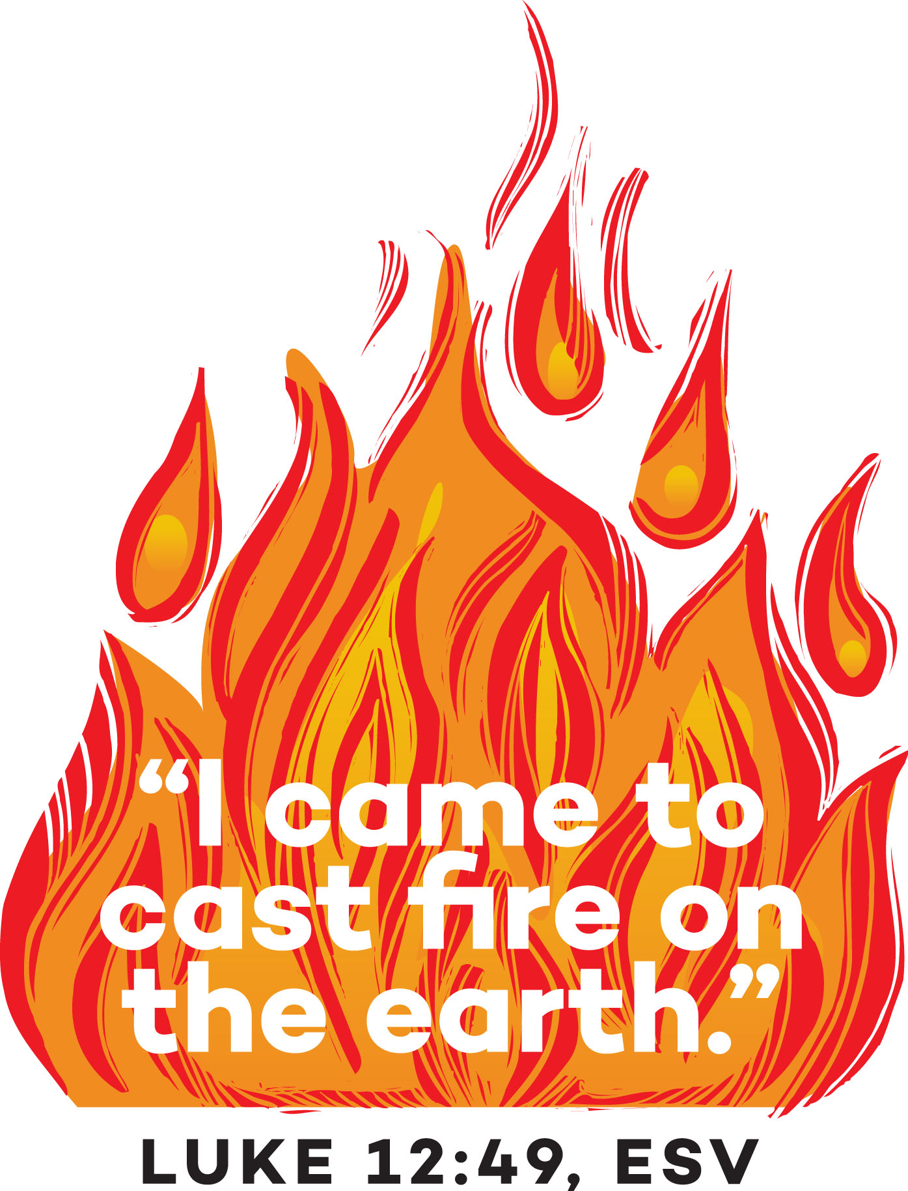

This Week’s Cathedral Schedule

TODAY (8/17) The Tenth Sunday after Pentecost/Proper 15
8:30 am Rite I Eucharist in All Saints Chapel (in-person only)
10:00 am Rite II Eucharist in the Cathedral (+ livestreamed, when available)
10:30a – 12:30p Full Gospel Community Church service – CHP

Thurs. (8/21)
11:00 am Calling hour for Anita Hill; funeral at 12:00 pm - CATH
4:15 – 5:30 pm TASK Meals – SH
4:45 pm Food Pantry food bagging
8:00 pm Society of Mary Rosary Devotions via Zoom and phone access: Please E-mail Erica Warner at vassose@aol.com for information on how to join us

Fri. (8/22)
10:00 am Wedding – CHP

Sat. (8/23)
9 – 11:00 am Food Pantry

Sun. (8/24) The Eleventh Sunday after Pentecost/Proper 16 ~ Family Sunday
10:00 am Rite II Eucharist in the Cathedral (+ livestreamed, when available)
10:30a – 12:30p Full Gospel Community Church service – CHP

